**Assignment - 4**

| Assignment Date | 22 October 2022 |
| --- | --- |
| TeamID | PNT2022TID40963 |
| Project name | Smart crop protection -IOT |
| Maximum Marks | 2 Marks |

**Question-1:**

Write code and connections in wokwi for ultrasonic sensor.Whenever distance is less than 100 cms send “Alert” to ibm cloud and display in device recent events.

**Solution:**

// Pins

const int TRIG_PIN = 7;

const int ECHO_PIN = 8;

// Anything over 400 cm (23200 us pulse) is "out of range"

const unsigned int MAX_DIST = 23200;

void setup() {

// The Trigger pin will tell the sensor to range find

pinMode(TRIG_PIN, OUTPUT);

digitalWrite(TRIG_PIN, LOW);

//Set Echo pin as input to measure the duration of

//pulses coming back from the distance sensor

pinMode(ECHO_PIN, INPUT);

// We'll use the serial monitor to view the sensor output

Serial.begin(9600);

}

void loop() {

unsigned long t1;

unsigned long t2;

unsigned long pulse_width;

float cm;

float inches;

// Hold the trigger pin high for at least 10 us

digitalWrite(TRIG_PIN, HIGH);

delayMicroseconds(10);

digitalWrite(TRIG_PIN, LOW);

// Wait for pulse on echo pin

while ( digitalRead(ECHO_PIN) == 0 );

// Measure how long the echo pin was held high (pulse width) // Note: the micros() counter will overflow after ~70 min t1 = micros();

while ( digitalRead(ECHO_PIN) == 1);

t2 = micros();

pulse_width = t2 - t1;

// Calculate distance in centimeters and inches. The constants // are found in the datasheet, and calculated from the assumed speed //of sound in air at sea level (~340 m/s).

cm = pulse_width / 58.0;

inches = pulse_width / 148.0;

// Print out results

if ( pulse_width > MAX_DIST ) {

Serial.println("Out of range");

} else {

Serial.println("*******************************"); Serial.print("The Measured Distance in cm : ");

Serial.println(cm);

if(cm<100){

// while(true){

Serial.println("Alert!!");

// }

}

Serial.print("*******************************"); }

// Wait at least 1000ms before next measurement

delay(1000);

}

**Output:**

**1)If the distance is less than 100 cms , it alerts.**

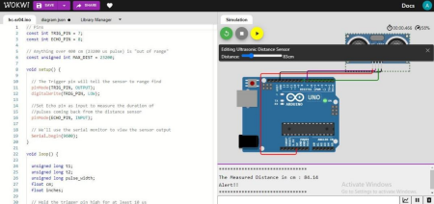

**2)If the distance is more than 100 cms, it won’t alert.**

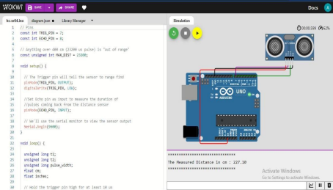

**3) Simulation and code execution**

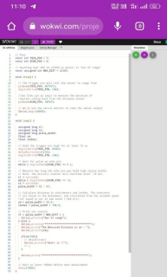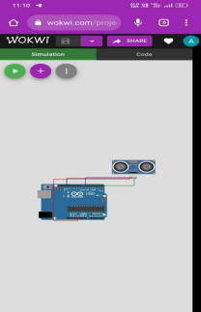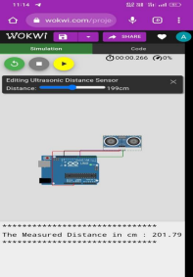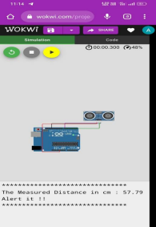

**Project Link:**

**https://wokwi.com/projects/346136429340918356**